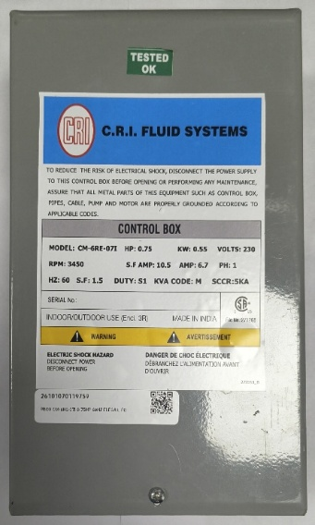
ELEGANT Technical specification:
TYPE | ELEGANT
MODEL | CM-6RP-05I | CM-6RE-05I | CM-6RE-07I | CM-6RE-10I
HP | 0.5 | 0.5 | 0.75 | 1
kW | 0.37 | 0.37 | 0.55 | 0.75
VOLTS | 115 | 230 | 230 | 230
RPM | 3450 | 3450 | 3450 | 3450
S.F.AMP | 16 | 8 | 10.5 | 12.5
AMP | 10 | 4.5 | 6.7 | 8.5
HZ | 60 | 60 | 60 | 60
S.F. | 1.6 | 1.6 | 1.5 | 1.4
DUTY | S1 | S1 | S1 | S1
KVA CODE | M | M | M | M
QD Relay | RVA2ALKL | RVA2ALKL | RVA2ALKL | RVA2ALKL
DIMENSION(MM) | 216L*123.5W*70.5D | 216L*123.5W*70.5D | 216L*123.5W*70.5D | 216L*123.5W*70.5D
WEIGHT(KG) | 1.25 | 1.25 | 1.25 | 1.25

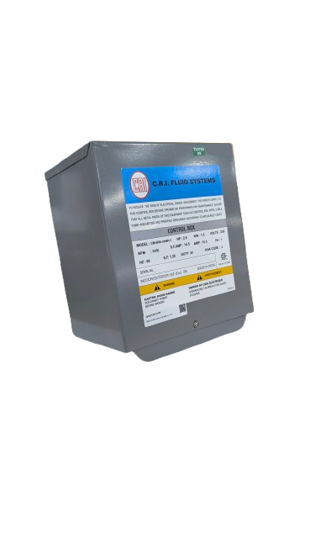

SMART PLUS Technical specification:
TYPE | SMART PLUS
MODEL | CM-6RE-15MP | CM-6RE-20MP | CM-6RE-30MP | CM-6RE-50MP
HP | 1.5 | 2 | 3 | 5
kW | 1.1 | 1.5 | 2.2 | 3.7
VOLTS | 230 | 230 | 230 | 230
RPM | 3450 | 3450 | 3450 | 3450
S.F.AMP | 13 | 14.5 | 19.5 | 27
AMP | 8.1 | 10.3 | 17 | 24
HZ | 60 | 60 | 60 | 60
S.F. | 1.3 | 1.25 | 1.15 | 1.15
DUTY | S1 | S1 | S1 | S1
KVA CODE | J | J | J | G
QD RELAY | RVA4ALKL | RVA2ALKL | RVA2ALKL | RVA2ALKL
OLP RATING | 15A | 18A | 25A | 30A
DIMENSION(MM) | 237L*202W*151D | 237L*202W*151D | 237L*202W*151D | 237L*202W*151D
WEIGHT(KG) | 3.28 | 3.28 | 3.28 | 3.28

DELUXE Technical specification:
TYPE | DELUXE
MODEL | CM-6RE-15MP-C | CM-6RE-20MP-C | CM-6RE-30MP-C | CM-6RE-50MP-C
HP | 1.5 | 2 | 3 | 5
kW | 1.1 | 1.5 | 2.2 | 3.7
VOLTS | 230 | 230 | 230 | 230
RPM | 3450 | 3450 | 3450 | 3450
S.F.AMP | 13 | 14.5 | 19.5 | 27
AMP | 8.1 | 10.3 | 17 | 24
HZ | 60 | 60 | 60 | 60
S.F. | 1.3 | 1.25 | 1.15 | 1.15
DUTY | S1 | S1 | S1 | S1
KVA CODE | J | J | J | G
QD Relay | RVA4ALKL | RVA2ALKL | RVA2ALKL | RVA2ALKL
OLP RATING | 15A | 18A | 25A | 30A
DIMENSION(MM) | 237L*202W*151D | 237L*202W*151D | 237L*202W*151D | 237L*202W*151D
WEIGHT(KG) | 3.28 | 3.28 | 3.28 | 3.28

